1- Design your online CV using the give template image

And use sass

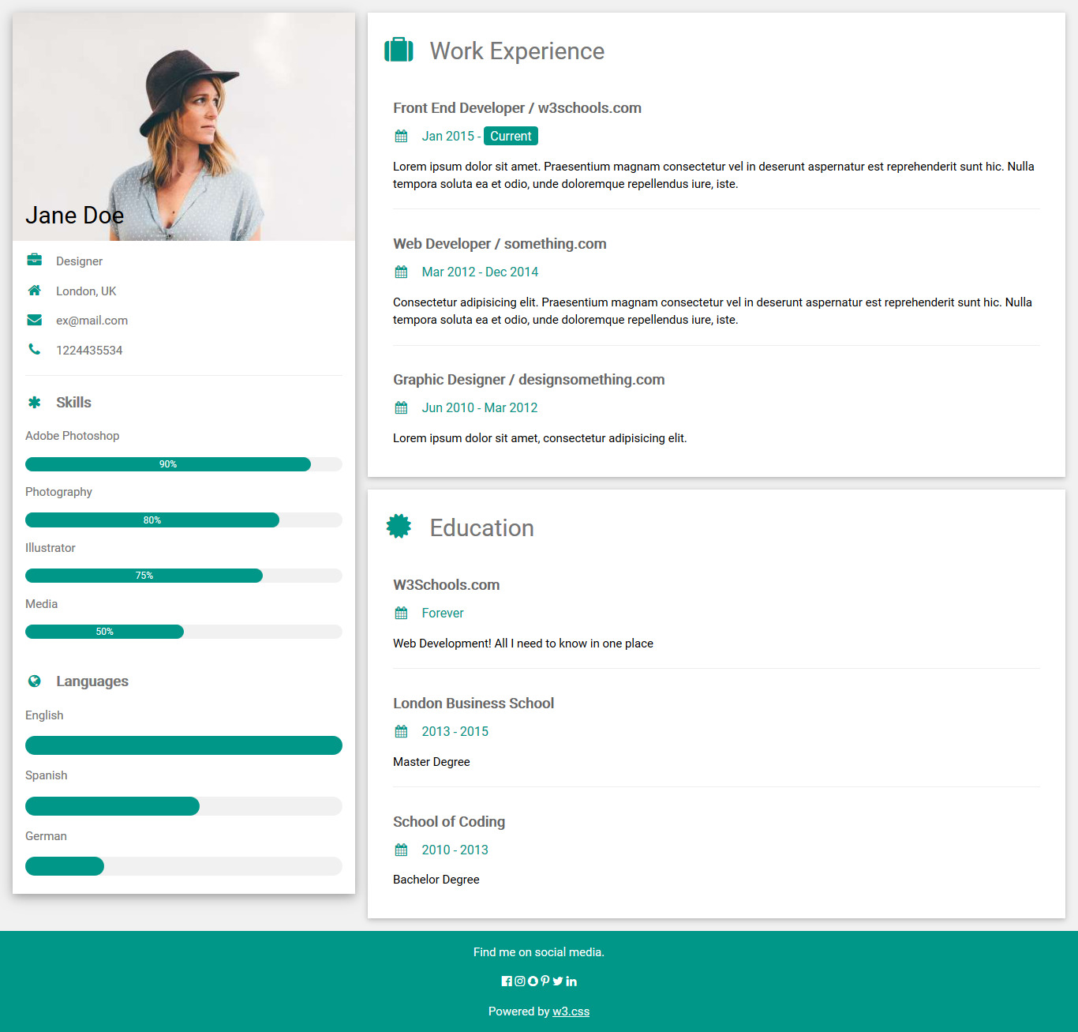

# 2- Complete on no 2 of day2 assignment

# a-Make Carousel

# b- Use Scrollspy

# E:\ITI Courses\Bootstrab\p2.png

## 